- We have raised our forecast for UK CPI inflation significantly over the next couple of years, reflecting the impact of the ongoing conflict in the Middle East. Higher oil prices are already feeding through to petrol prices, and we expect domestic energy bills to rise by 21% from July. The spike in oil and gas prices is also expected to lift the prices of other goods and services.
- Under our baseline oil and gas price assumptions, CPI inflation is forecast to reach 4.5% in H2 2026 and average 3.9% over 2026 as a whole. Strong base effects will pull inflation down in 2027. But there's significant uncertainty around the impact of the conflict on oil and gas prices.
CPI inflation was unchanged at 3% in February. The fuel category weighed more heavily on inflation, with a 1.1% m/m drop in petrol prices between January and February contrasting with a 1.5% increase in the same period last year. Meanwhile, services and food price inflation also cooled. But these movements were offset by upward pressure from the core goods category, which largely reflected the comparison with last year's unusually soft outturn in the clothing sub-category. Elsewhere, RPI and RPIX inflation fell by 0.2ppts to sit at 3.6% and 3.5% in February.
We expect CPI inflation to accelerate in the coming months as the impact of the Middle East conflict feeds through. There's significant uncertainty around the duration of the conflict and its impact on oil and gas prices. Our baseline forecast assumes disruption in the Strait of Hormuz and damage to energy infrastructure will keep oil and gas prices high in Q2 before gradually dropping back. Higher oil prices are already pushing up fuel prices significantly. Our gas price assumption is consistent with the Ofgem Energy Price Cap rising by 21% in July. We also anticipate some passthrough of higher fuel and energy costs for businesses to other parts of the inflation basket, such as food prices and the more energy-intensive parts of core inflation. We think second round effects via higher pay growth will be more limited than in 2022-2023 due to much looser labour market conditions and weak activity.
Our new forecast shows CPI inflation reaching 4.5% in H2 2026, and averaging 3.9% over 2026 as a whole. Strong base effects then drag inflation below the Bank of England's 2% target in H2 2027.
Chart 1: We've raised our CPI inflation forecast significantly due to the conflict in the Middle East
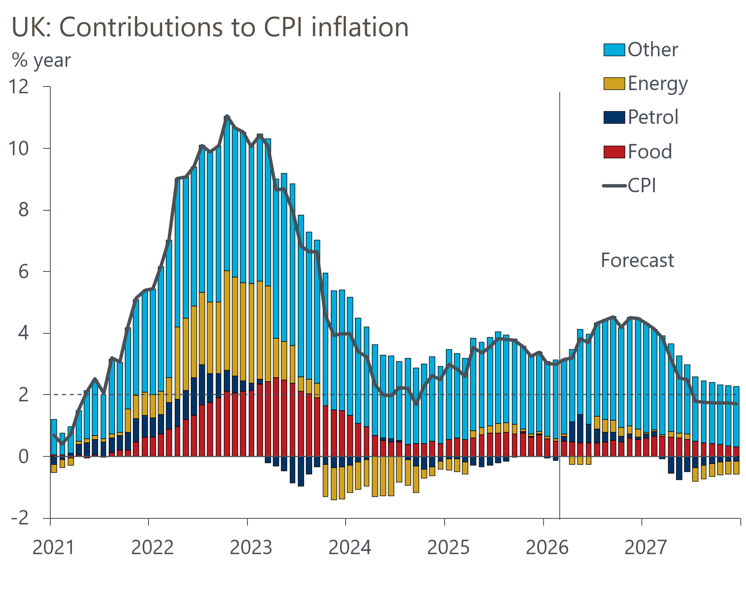
Source: Oxford Economics, Haver Analytics

